POSITION TITLE: INFECTIOUS DISEASES CLINICAL PHARMACIST
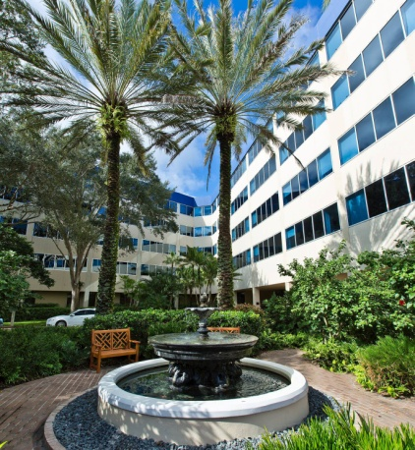
THE ORGANIZATION:
Celebrating nearly 85 years of caring for our community, Indian River Medical Center is an award-winning 332-bed not-for-profit hospital centrally located on Florida’s Treasure Coast. An integral part of the healthcare community, IRMC is well known for our award-winning Duke-affiliated Welsh Heart Center, comprehensive cancer program at Scully Welsh Cancer Center, and nationally-recognized vascular surgery and orthopedic services. The hospital boasts a modern Emergency Department, a state-of-the-art wound healing center, and a maternity wing that welcomes more than 1,200 babies into the world each year. IRMC is also privileged to be a part of both the Duke Antimicrobial Stewardship Outreach Network (DASON) and Duke Infection Control Outreach Network (DICON).

BASIC FUNCTION:
The pharmacist provides pharmaceutical care to hospitalized or ambulatory patients and manages anti-infective quality initiative projects by coordinating programs from Pharmacy, Infectious Diseases, Clinical Microbiology, Infection Prevention, and Quality. The pharmacist participates in the Pharmacy and Therapeutics Committee process to assist in developing and maintaining an anti-infective formulary, antibiotic use policies and clinical pathways related to treatment of infections. He or she provides prospective review of antimicrobial utilization and microbiology data to optimize patient care and documents those activities. The Infectious Diseases Clinical Pharmacist develops and implements staff development programs for pharmacists, mentors pharmacy residents and students, and provides in-service education to physicians, nurses, and medical students. Involvement in research initiatives is encouraged. The pharmacist is expected to rotate through the centralized distribution process on weekends on a limited basis.

NATURE AND SCOPE:
The Infectious Diseases Clinical Pharmacist reports to the Director of Pharmacy and indirectly to the Clinical Pharmacy Manager and the Pharmacy Operations Manager. Serves as co-chair of the Antimicrobial Stewardship Subcommittee of the Pharmacy and Therapeutics Committee. This individual will interact with physicians and pharmacists to establish timely treatment, as well as with various data analysts to monitor drug use and identify areas of potential improvement.

JOB REQUIREMENTS:
Required: PharmD or BS Pharmacy
Active Florida pharmacy license or eligible
ASHP-accredited PGY1 residency or minimum 3 years clinical experience

Preferred: PGY2 infectious diseases residency or equivalent experience
Board certification in pharmacotherapy
Experience with Patient Event Advsior as well as McKesson products

CONTACT:
Bruce Madara, RPh, CPh Lorna Landherr Dayla Boldt, PharmD, BCPS-AQID
Pharmacy Director Human Resources ID Clinical Pharmacist
(772) 567-4311 x1243 (772) 567-4311 x2833 (772) 567-4311 x3796
bruce.madara@irmc.cc lorna.landherr@irmc.cc dayla.boldt@irmc.cc

*Job description has been abbreviated to facilitate posting.

