Vancomycin AUC-Based Monitoring Educational Document for Nursing Staff

- Background
  - Vancomycin is a commonly prescribed antibiotic for infections caused by Gram-positive organisms
  - Vancomycin has a narrow therapeutic index, meaning that therapeutic and toxic level are relatively close; therefore, therapeutic drug monitoring (TDM) is performed to maximize efficacy and minimize toxicity (i.e. nephrotoxicity)
  - Vancomycin TDM has traditionally been guided by trough-only monitoring where a single vancomycin serum level is drawn approximately 30 minutes before the next scheduled dose
  - This approach is being revised to an area-under-the-concentration-time-curve (AUC)-based monitoring method that uses one or two vancomycin serum levels
  - Goal AUC ratio ~400-600 mg*h/L
  - Why are we switching to AUC-based monitoring?
    - AUC-based monitoring is more accurate than trough-based monitoring for vancomycin efficacy and toxicity
    - Troughs serve as a poor predictor of AUC
    - Evidence demonstrates that target AUC of 400-600 mg*h/L can be achieved with troughs of 10-15 mg/L for many patients → lower vancomycin doses per day typically required
    - Decreased risk of nephrotoxicity with AUC-based monitoring compared to trough-based monitoring
- Indications for vancomycin AUC-based monitoring (may vary depending on each institution)
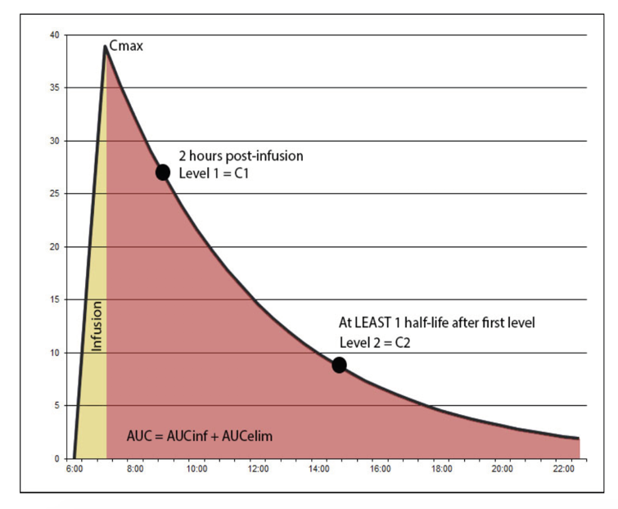
  - Generally, whenever vancomycin is used for documented or suspected methicillin-resistant Staphylococcus aureus infections EXCEPT:
    - Patients expected to receive vancomycin for <24 hours (i.e. surgical prophylaxis)
    - Unstable or fluctuating renal function (i.e. acute kidney injury)
    - Renal replacement therapy (i.e. hemodialysis)
- How is AUC-based monitoring performed?
  - AUC-based monitoring is performed by collection of two vancomycin serum levels
  - Vancomycin serum levels are typically collected following the same dose (same dosing interval); however, they may be on different dosing intervals and extrapolated in certain clinical scenarios for ease of timing/logistics
    - C1= “peak”
      - Generally, should be collected at least 1-2 hours following the end of the vancomycin infusion
        - Avoids collection of the serum level during vancomycin post-infusion distribution phase and is more lenient for changes in vancomycin administration time
      - Typical range: ~30-40 mg/L (varies based on institution)
    - C2= “trough”
      - Generally, should be collected 30 minutes before the next dose
      - Typical range: ~10-20 mg/L (varies based on institution)
    - There should be a minimum of 4 hours between these levels (typically at least one vancomycin half-life)
- Nurses’ role for vancomycin AUC-based monitoring
  - Inaccurate vancomycin levels can affect patient safety, hospital length of stay, and drug/laboratory costs
  - For this strategy to work, timing is of the essence, and nursing collaboration is essential for getting this right!
    - Assist in the appropriate collection and timing of vancomycin serum levels
      - Do not hold vancomycin dose to wait for vancomycin serum level to return unless directed to do so by the pharmacist or prescriber
    - Provide timely administration of vancomycin as scheduled (including barcode scanning for documentation purposes)
      - Improves accuracy and interpretation of vancomycin serum levels
    - Contact pharmacists with any concerns or questions related to collection of vancomycin serum levels
    - If the second level is due after your shift, please be sure to include this in your hand-off to the oncoming nurse
  - Pharmacist or providers will order vancomycin serum levels in EMR
  - Pharmacists are encouraged to include text comments on the order for appropriate timing
    - Ex: “please collect vancomycin serum level 30 minutes prior to vancomycin dose scheduled at 2100”
  - Pharmacists are encouraged to contact nurses via EMR chat functions or through MAR chart reminders to alert nurses of when the vancomycin serum levels are ordered/scheduled
- Example AUC-based monitoring scenario for nurses
  - Vancomycin dosing regimen: 1000 mg IV every 12 hours administered over 1 hour (scheduled for 0900 and 2100)
  - Vancomycin serum levels ordered with 0900 dosing interval
    - Infusion is scheduled to end at 1000 (one-hour infusion)
  - Vancomycin C1 serum level (first level) ordered at 1200 (2 hours after the end of the infusion)
  - Vancomycin C2 serum level ordered for 2030 (30 minutes prior to next scheduled dose at 2100)
  - Pharmacist and/or provider will perform vancomycin pharmacokinetic calculations to calculate AUC to MIC ratio to guide subsequent vancomycin dosing regimens
- Thank you for all of your help with vancomycin monitoring to improve our patients’ care!
  - Please reach out to your pharmacist if you have any questions or concerns!

